Attach and Detach EBS volume

Create EC2 instance

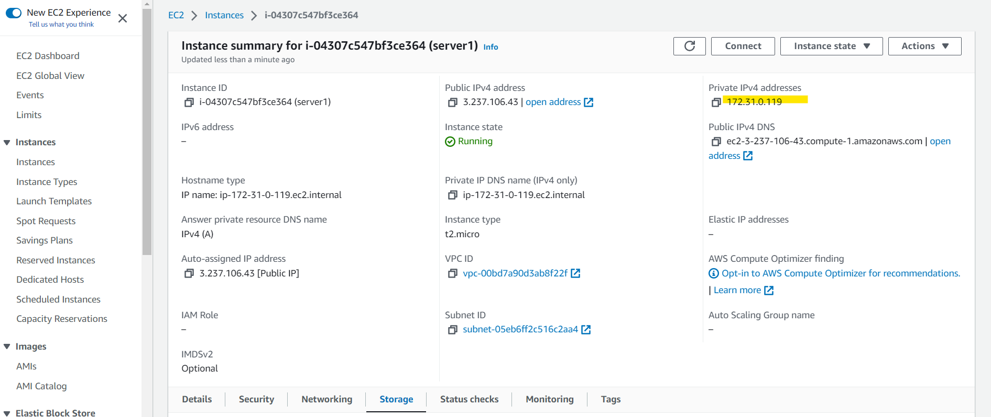

Storage

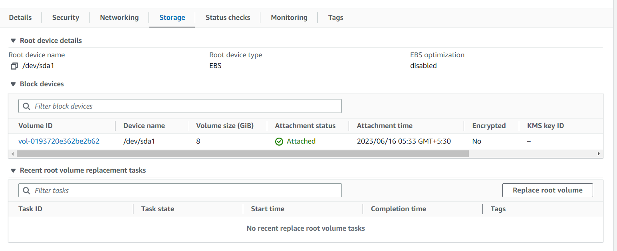

Create EBS volume in the EC2 AZ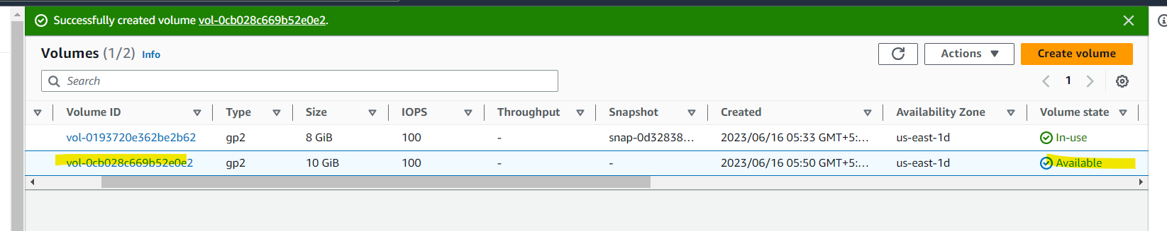

Attach the EBS to EC2 instance

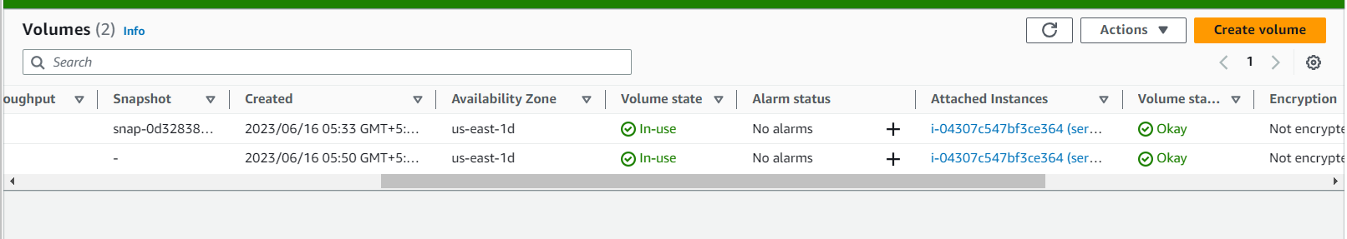

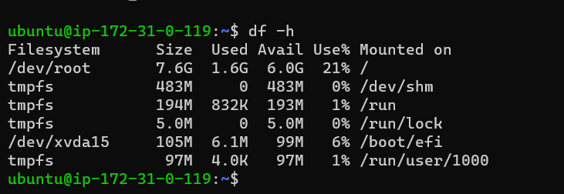

List all the block devices in linux machine

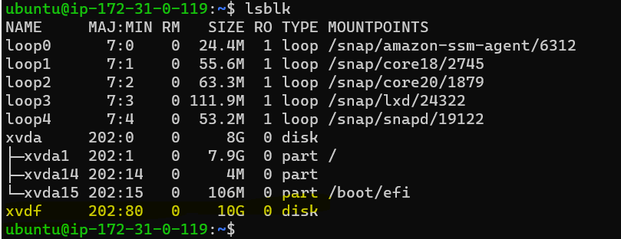

Create a file system on EBS

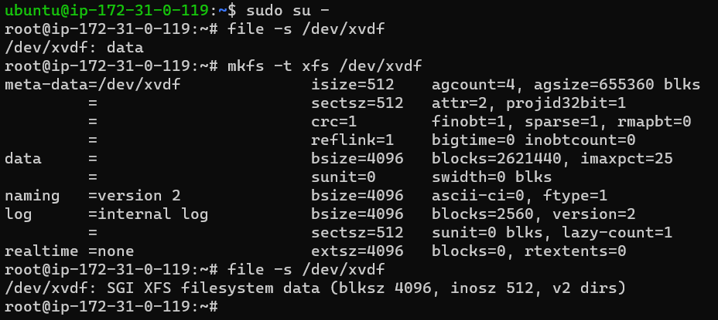

Mount the EBS





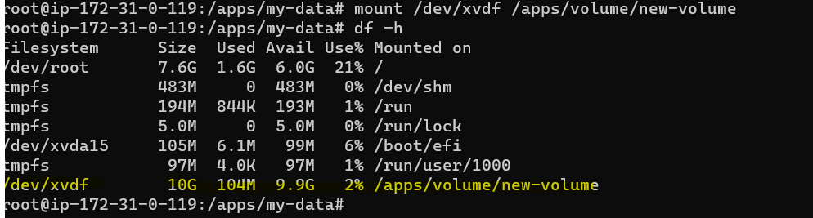

Create a File

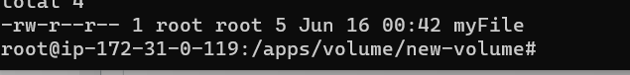

EBS is attached and mounted

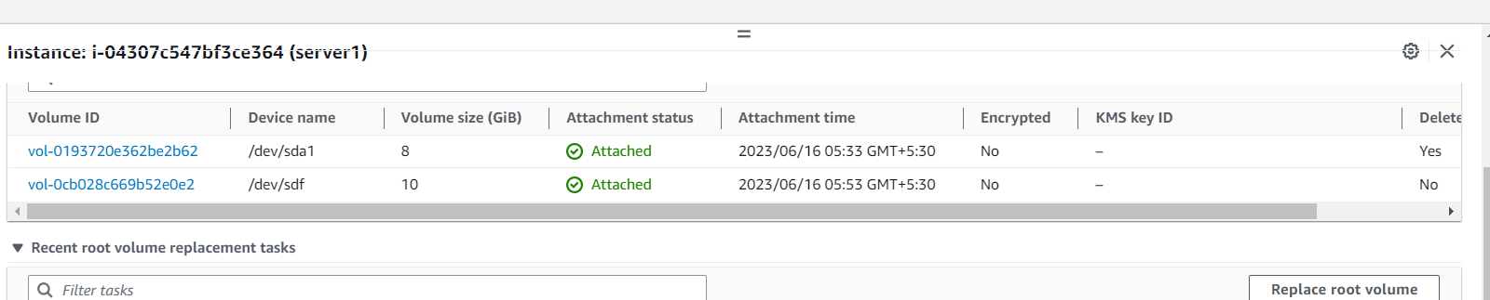

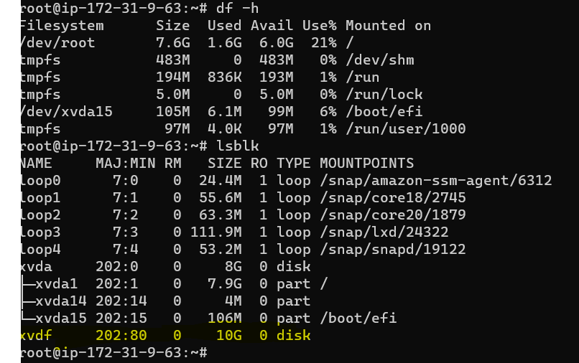

Mount the EBS

Detach volume

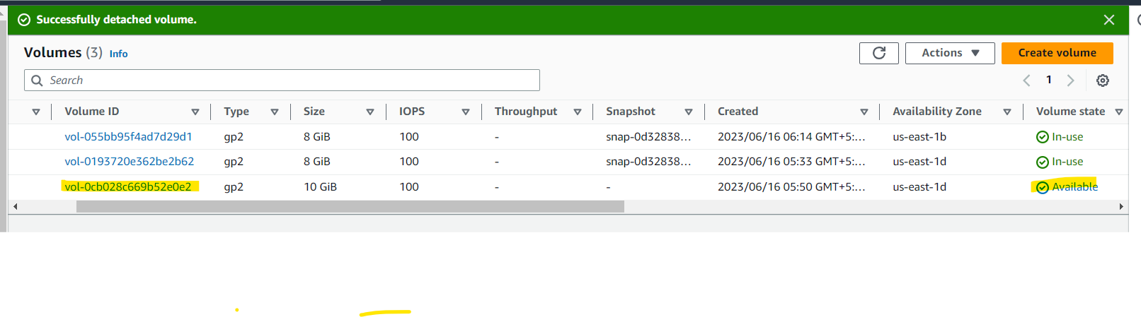

Attach the EBS to new EC2(server2)

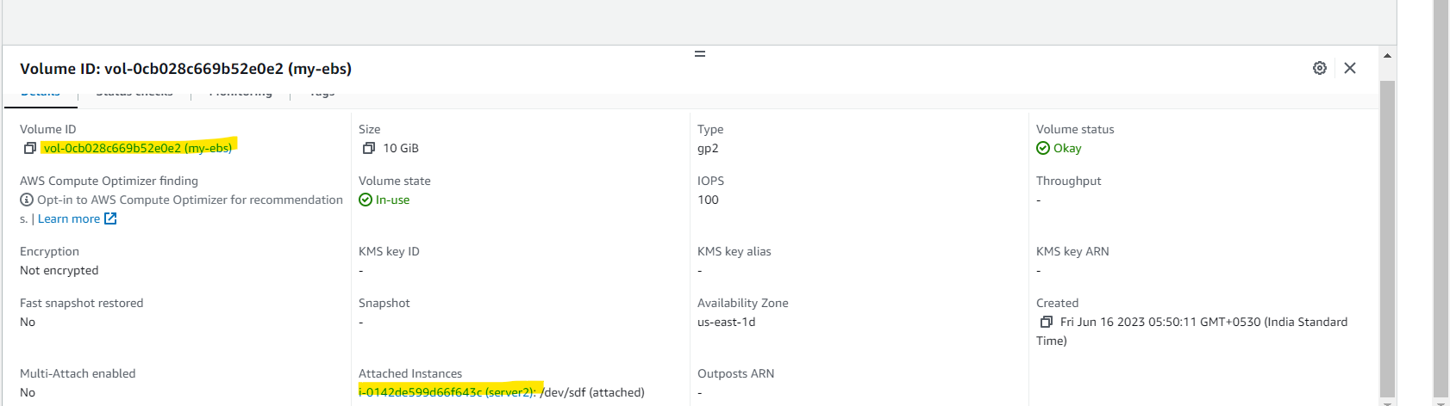

Mount EBS and check myFile is present

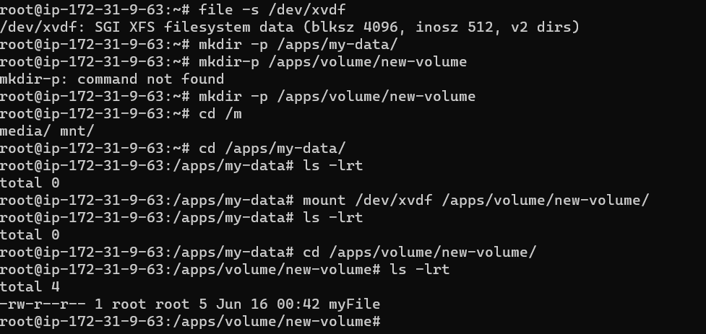

Create S3 from AWS CLI

